Description on how to download historical and last-trade data from godmode-trader.de:

We can download historical data from the godmode web page:

http://www.godmode-trader.de/profil/kurshistorie/instrumentId/133979

and last-trade data from:

http://www.godmode-trader.de/profil/aktie/instrumentId/133979

Set-up:

- Copy the following 2 lines and append to your existing “mywebserver.txt

godmode_DL,http://www.godmode-trader.de/profil/aktie/instrumentId/SSSS,L1,godmode_L1.fmt
godmode_DL,http://www.godmode-trader.de/profil/kurshistorie/instrumentId/SSSS/exchangeId/57/orderBy/date/orderDirection/DESC/seite/NN1N#results,D1,godmode3_D1.fmt

- Copy the “godmode_L1.fmt” and the “godmode3_D1.fmt” files to the “fmt” subfolder.
- Run HSQuote Plus and set up the screen as shown.

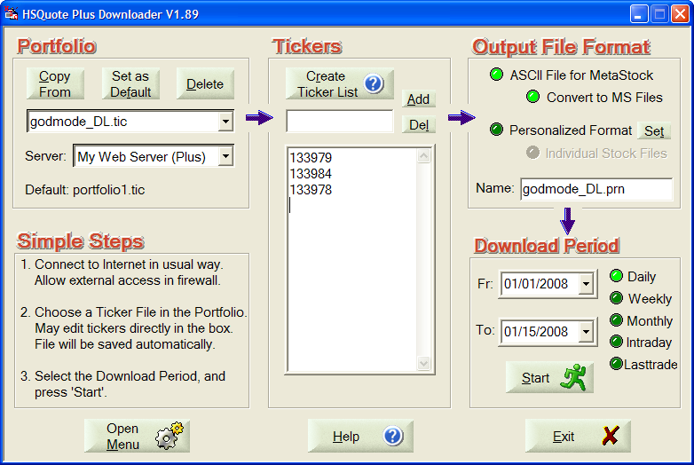

Historical Daily Data Download:

This simple implementation can fetch about 5 years of data. You just select the date range and Daily, and Start download.

Last-Trade Data Download:

We can use the same portfolio ticker list “godmode_DL.tic” so that both last-trade and historical data for the same stocks are stored in the same MetaStock data files. You just need to select Lasttrade for the download.

